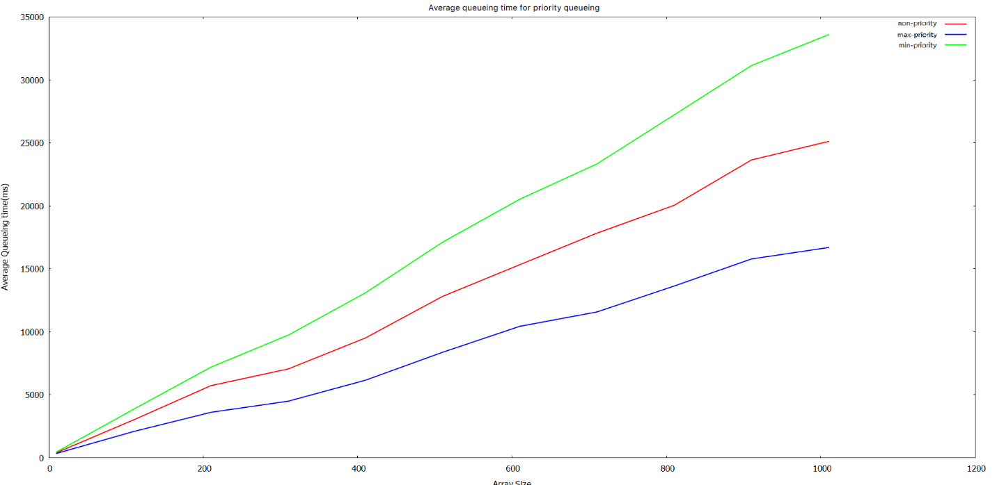

As picture shown, the reverse-priority is the slowest; second is non-priority and the max-priority is the fastest.

Data as follows

n A_Avg B_Avg C_Avg

10 415 352 474

110 3022 2096 3867

210 5732 3614 7202

310 7056 4497 9743

410 9515 6162 13099

510 12818 8381 17121

610 15333 10440 20532

710 17840 11584 23336

810 20050 13642 27231

910 23645 15786 31139

1010 25120 16697 33594